Kristen Trunnelle

IST 590

Week 9 Lab

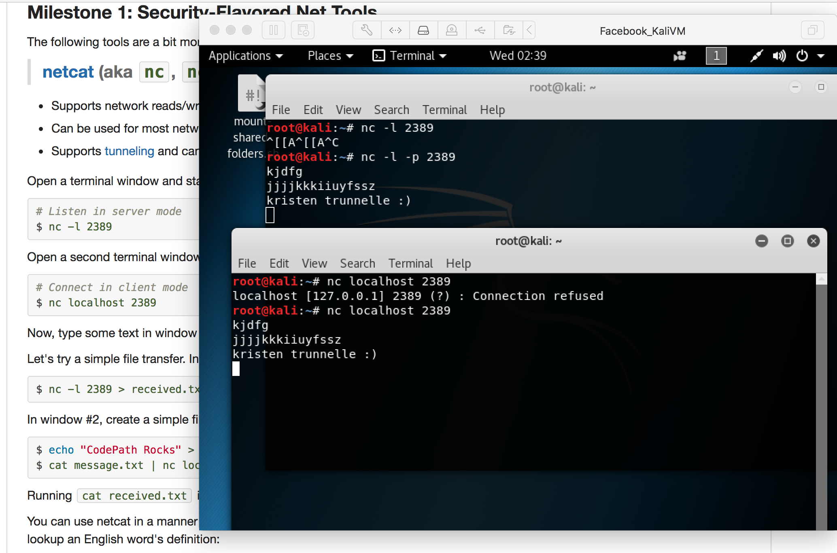

I did the first two commands and they didn’t work so I googled it and saw to add a -p which then made it work.

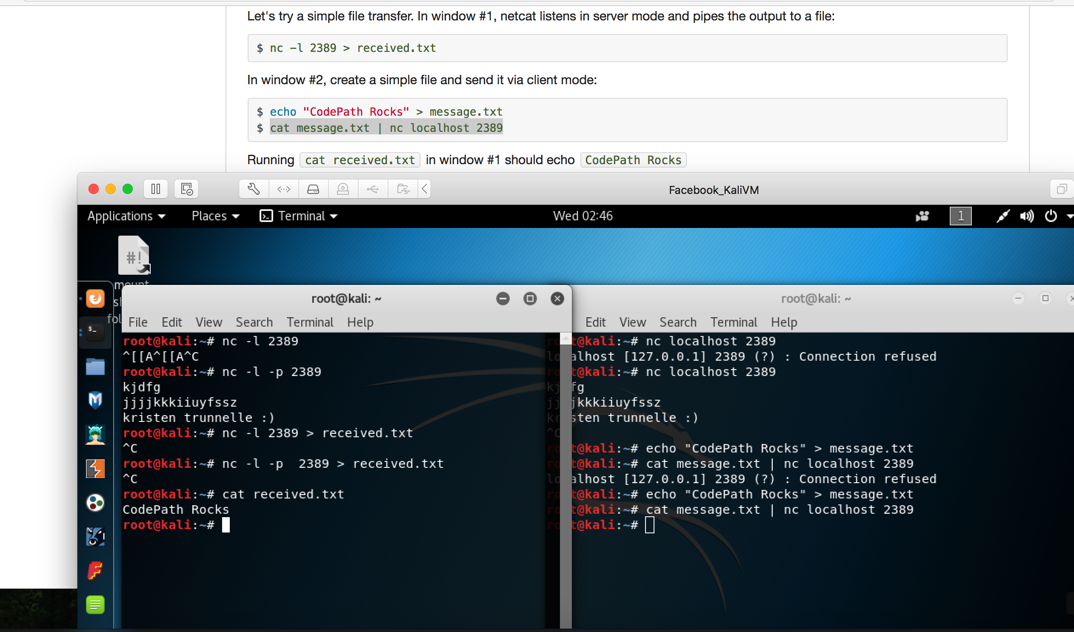

This picture shows that it worked and the message I wrote on one appeared on the other one too.

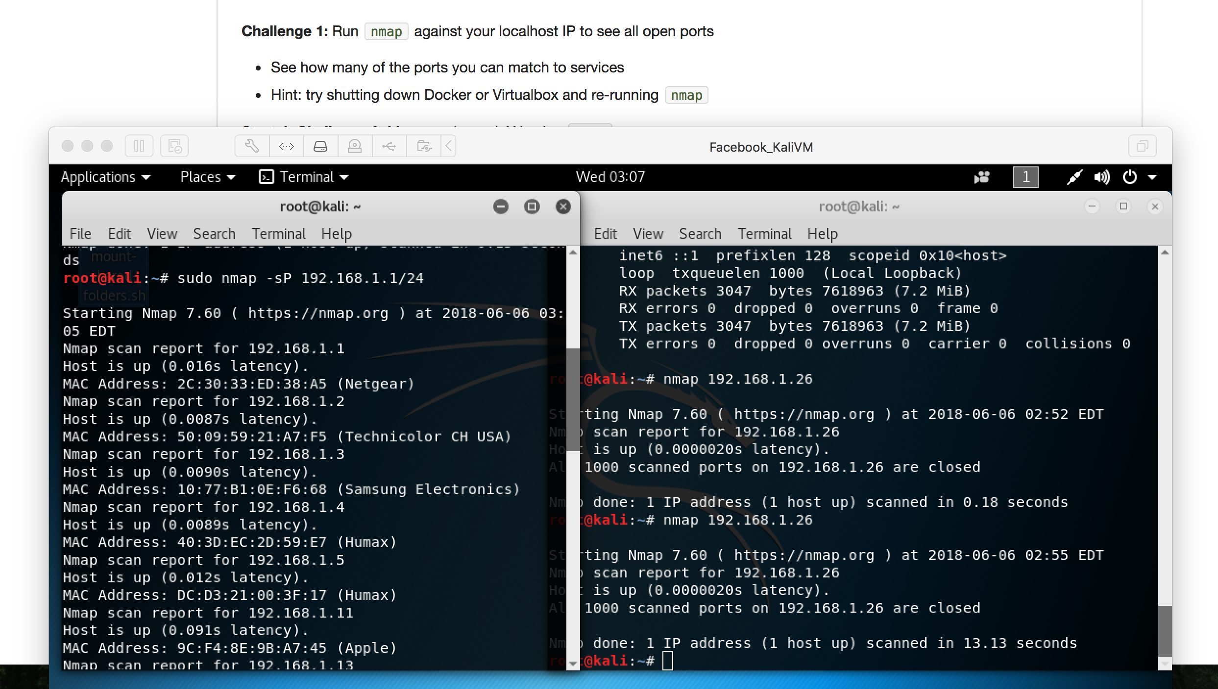

Copied the command given in this step and it ran nmap on my mac’s IP address.

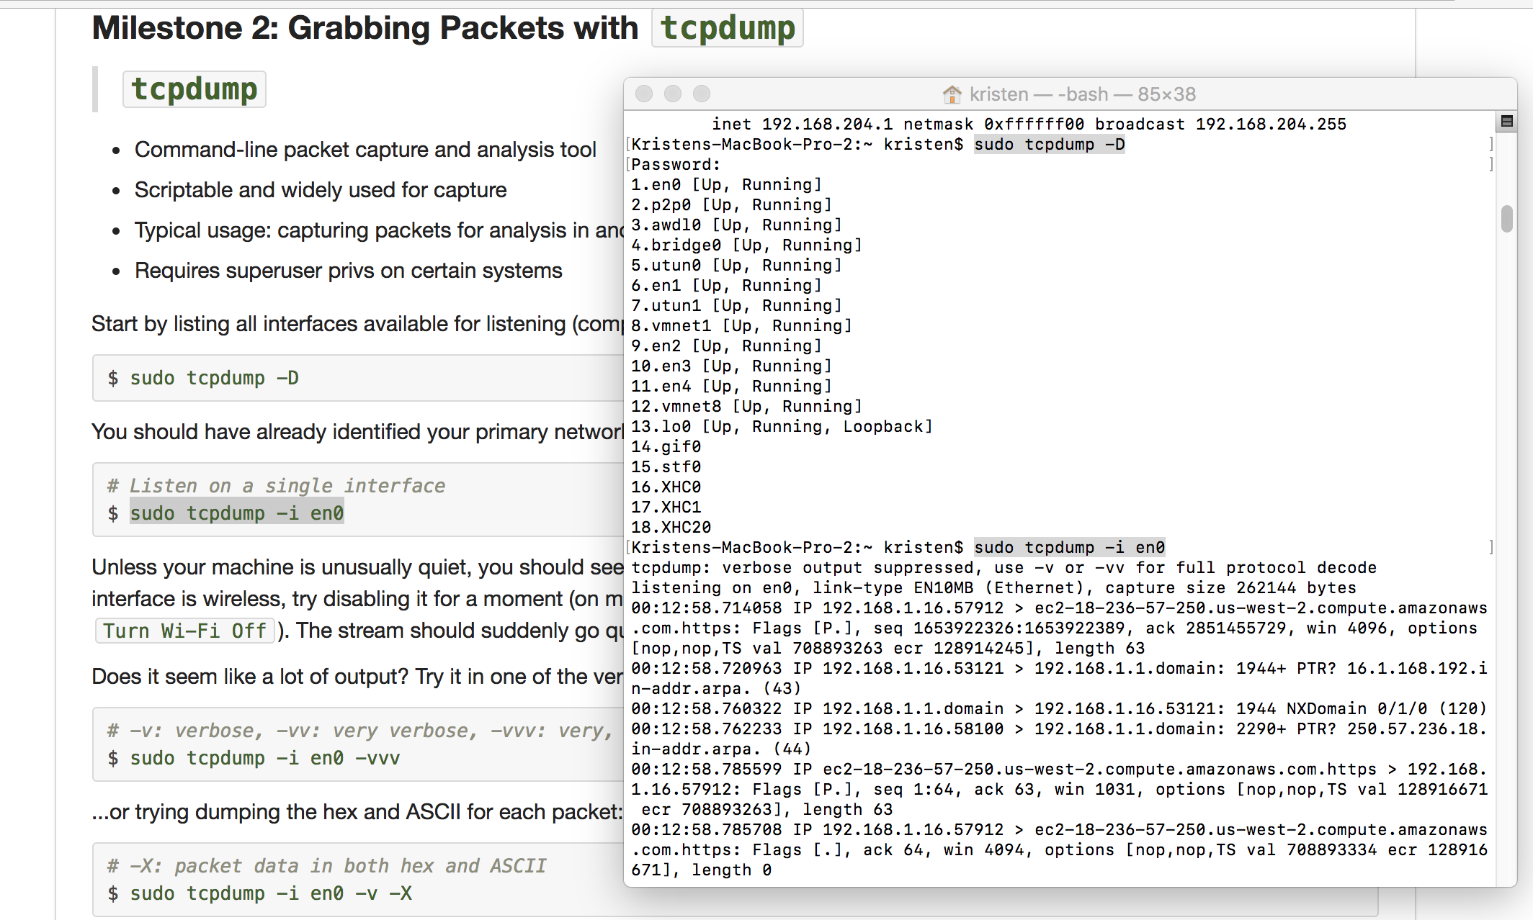

These two steps both shown above both worked.

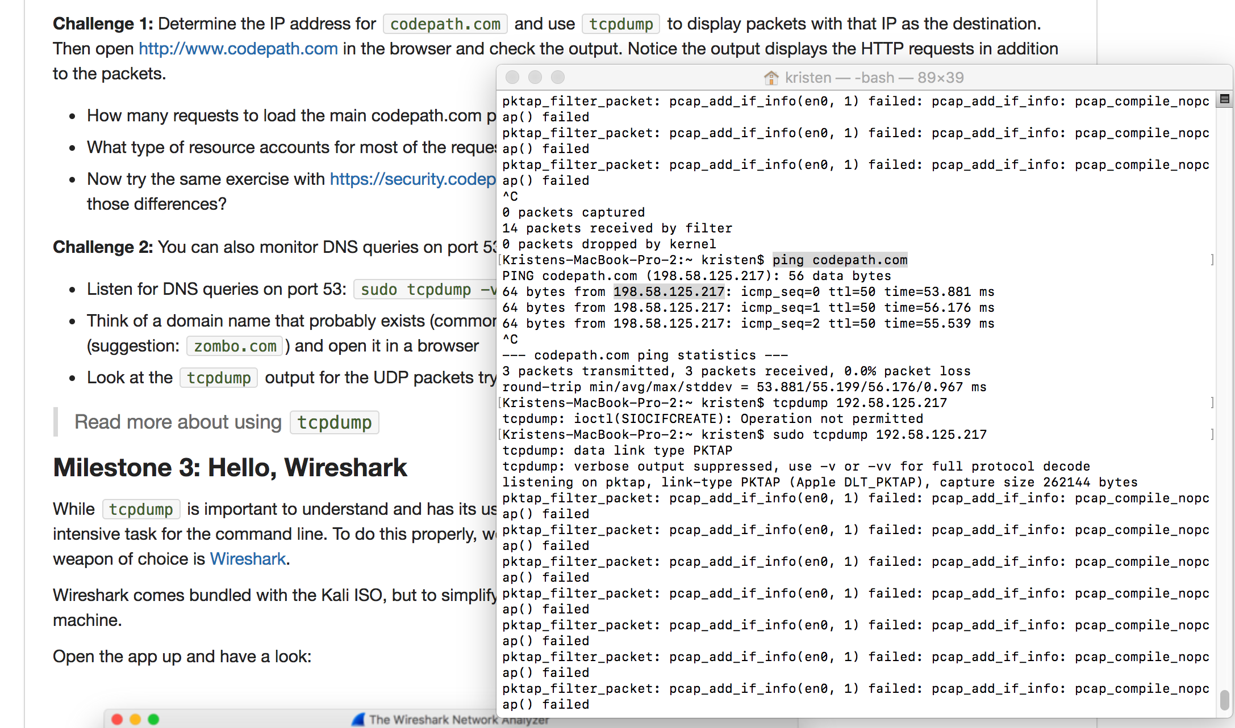

For some reason I was able to get codepath.com’s IP address but not run tcpdump on it. It wouldn’t let me get the 2nd security.codepath’s IP though even though I tried to ping it.

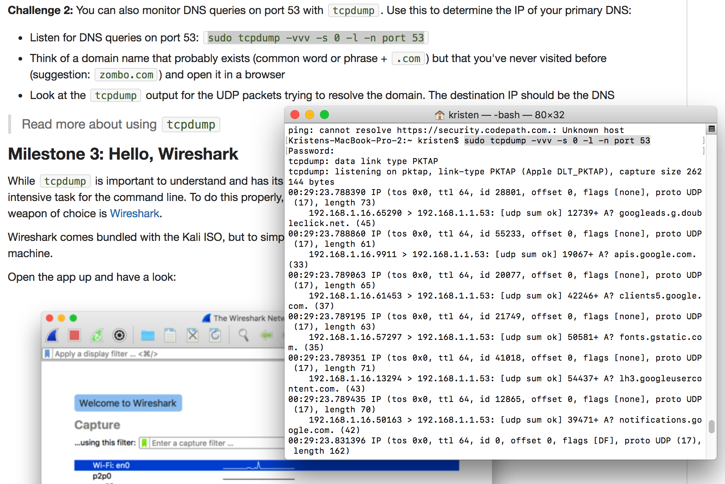

The command worked as shown.

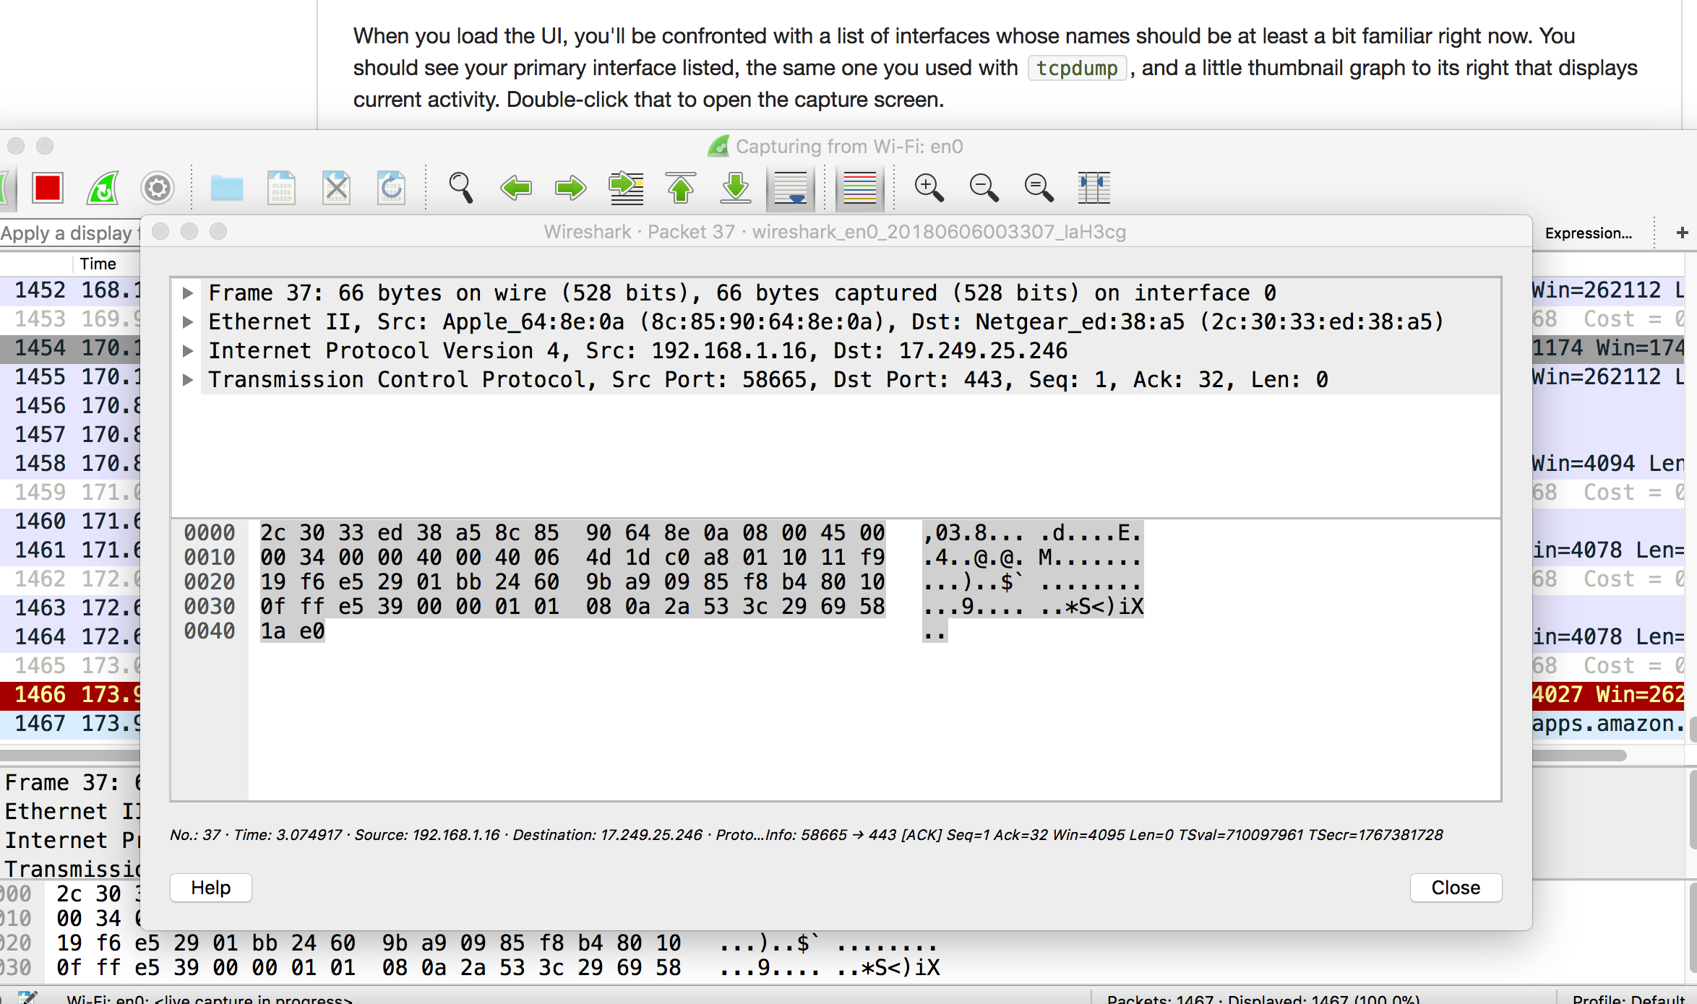

I saw my IP address listed in the 1,000s of pieces of traffic. I think I clicked up the above picture of a different IP address shown on Wireshark though.

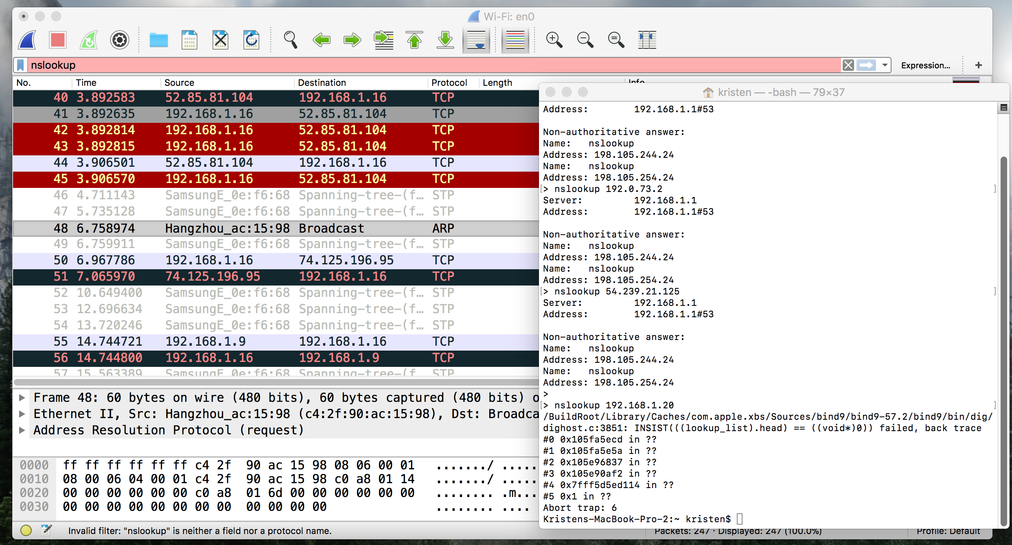

I ran nslookup on some of the IP addresses shown in the Wireshark capture.

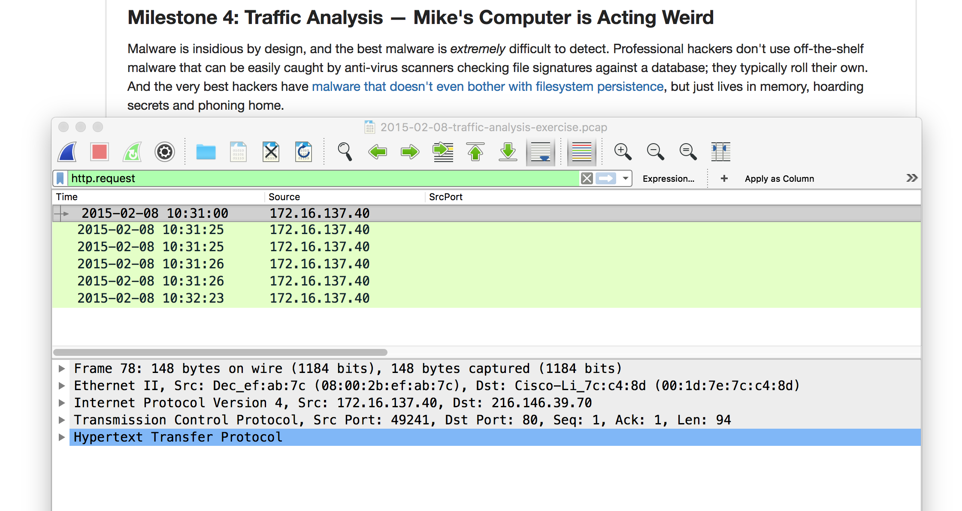

I did not see the section at first to add the column then tried and it wouldn’t add it as a column. The traffic is from the first pcap file.

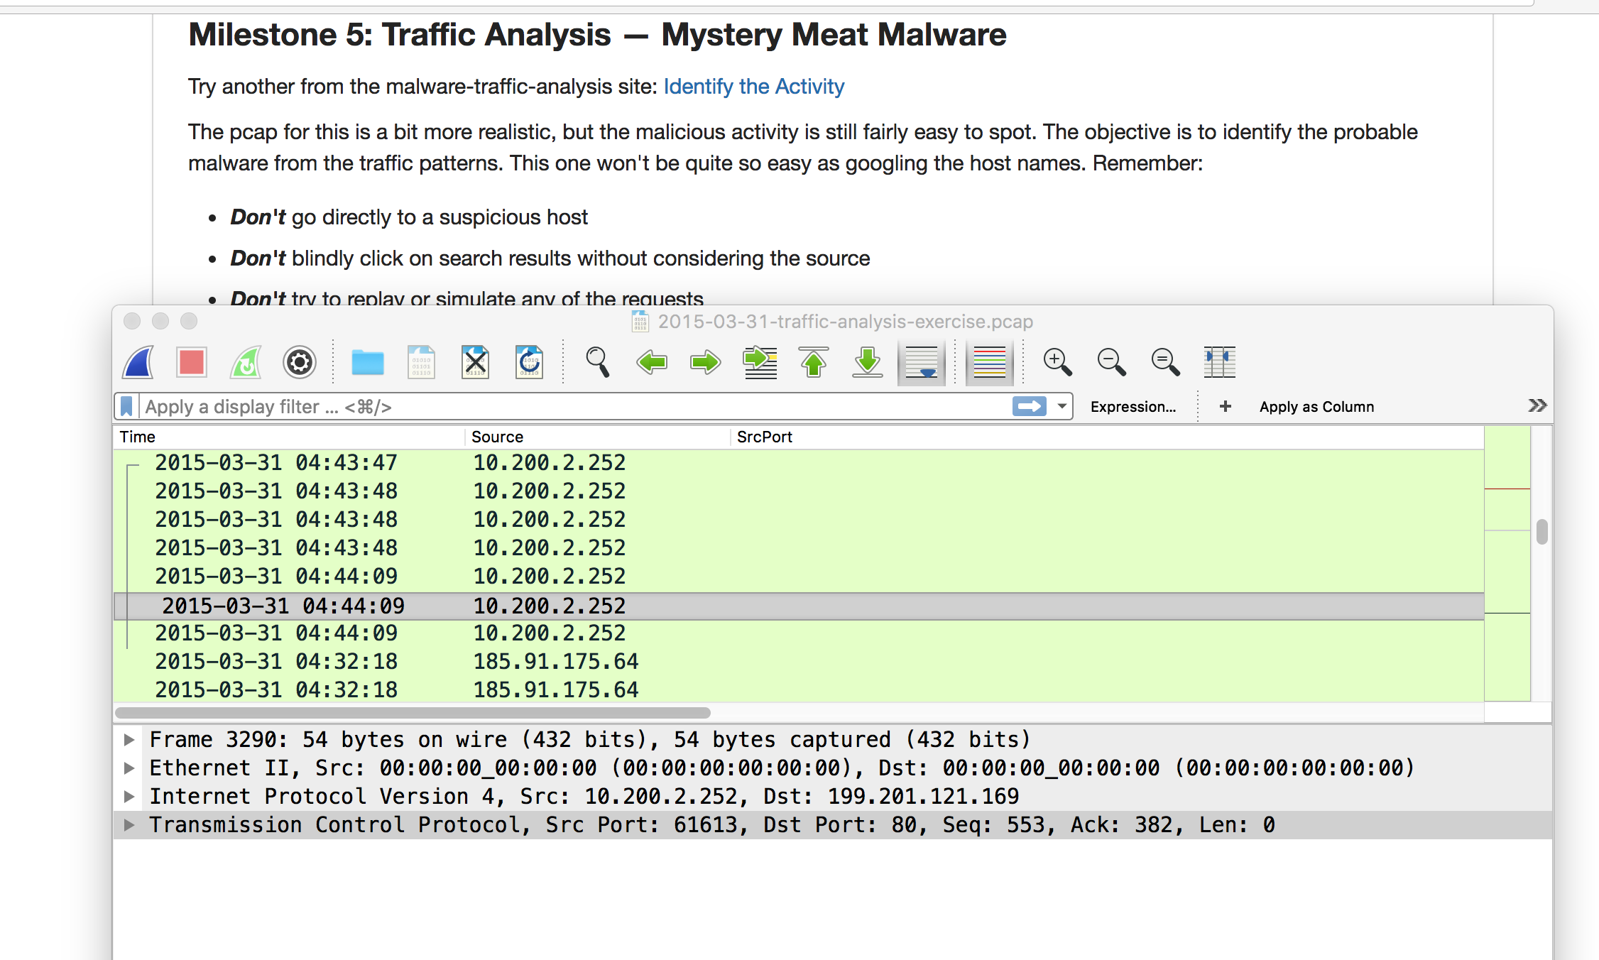

Same as above, only limited columns showing and second pcap from zip file is running.

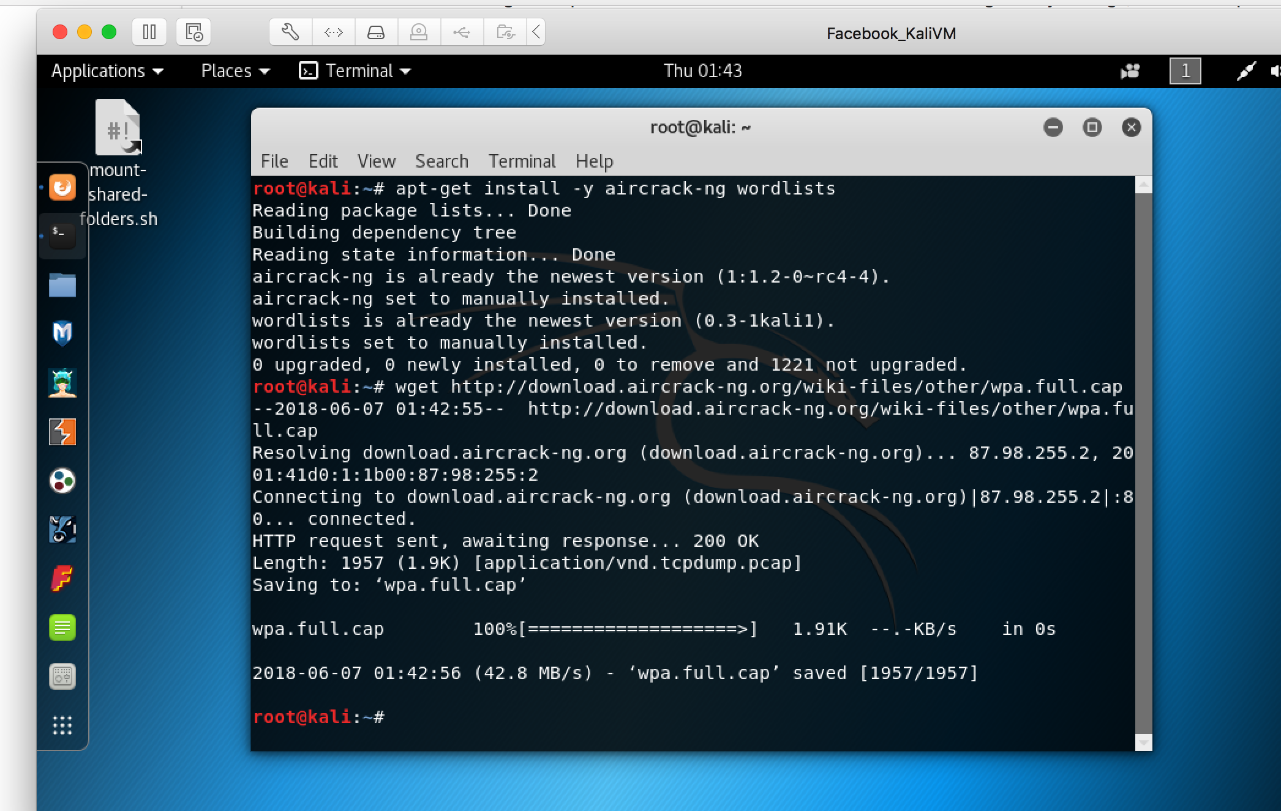

The shown command worked.

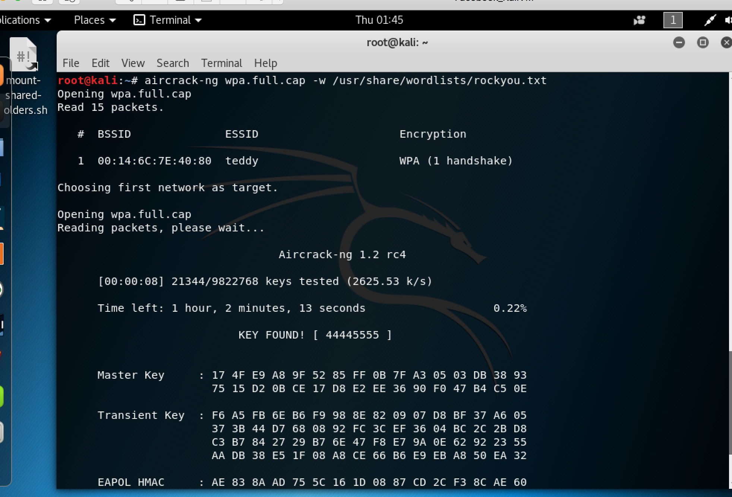

It ran the given aircrack-ng command.

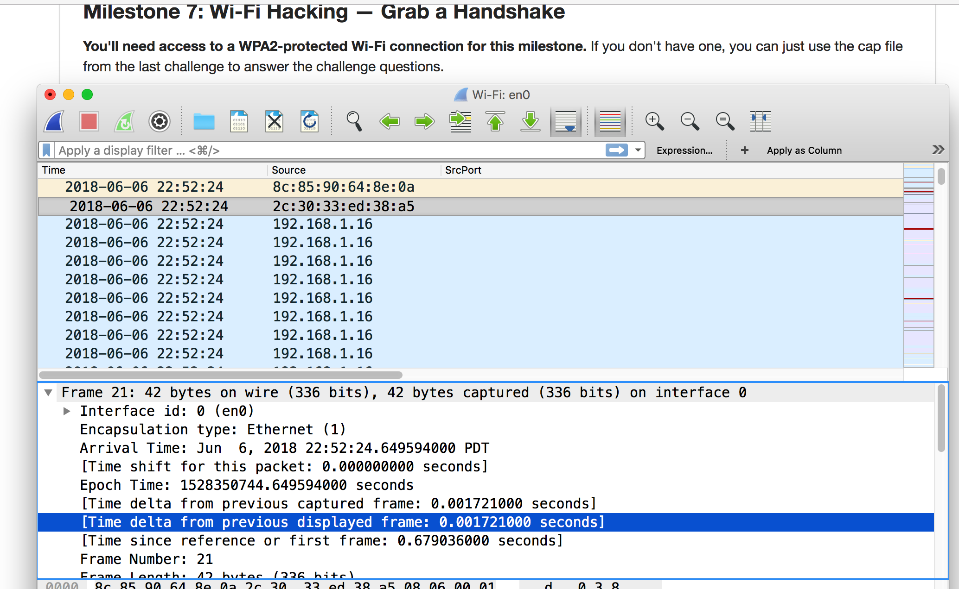

Since I failed to notice the part of the second box that I was supposed to right click and add as a column, I could not tell what Wireshark was showing me with only the two columns. In the above picture, it looks like two mac addresses and the rest is my IP addresses repeated.

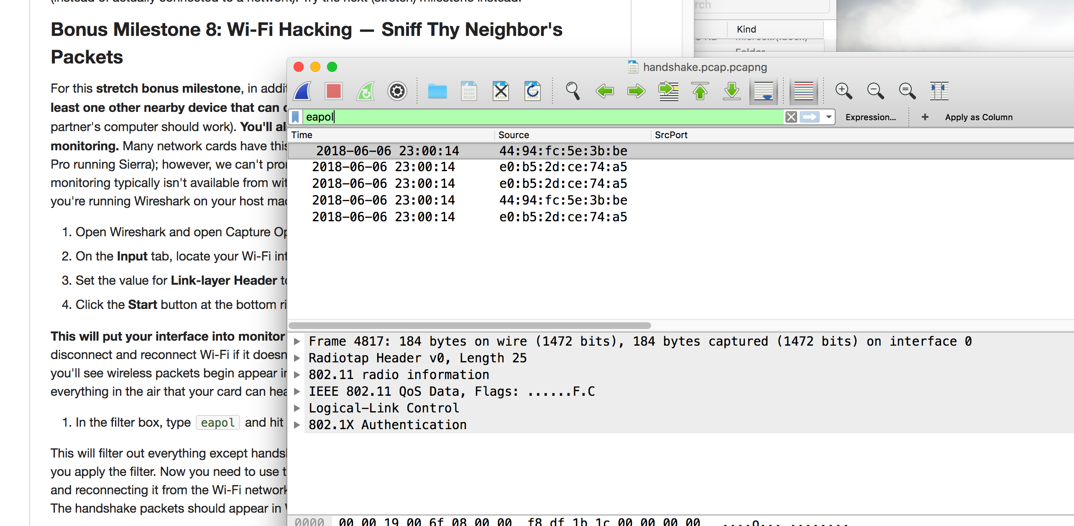

Did all the way down to the eapol command where I was supposed to have more results but with only two columns I didn’t.

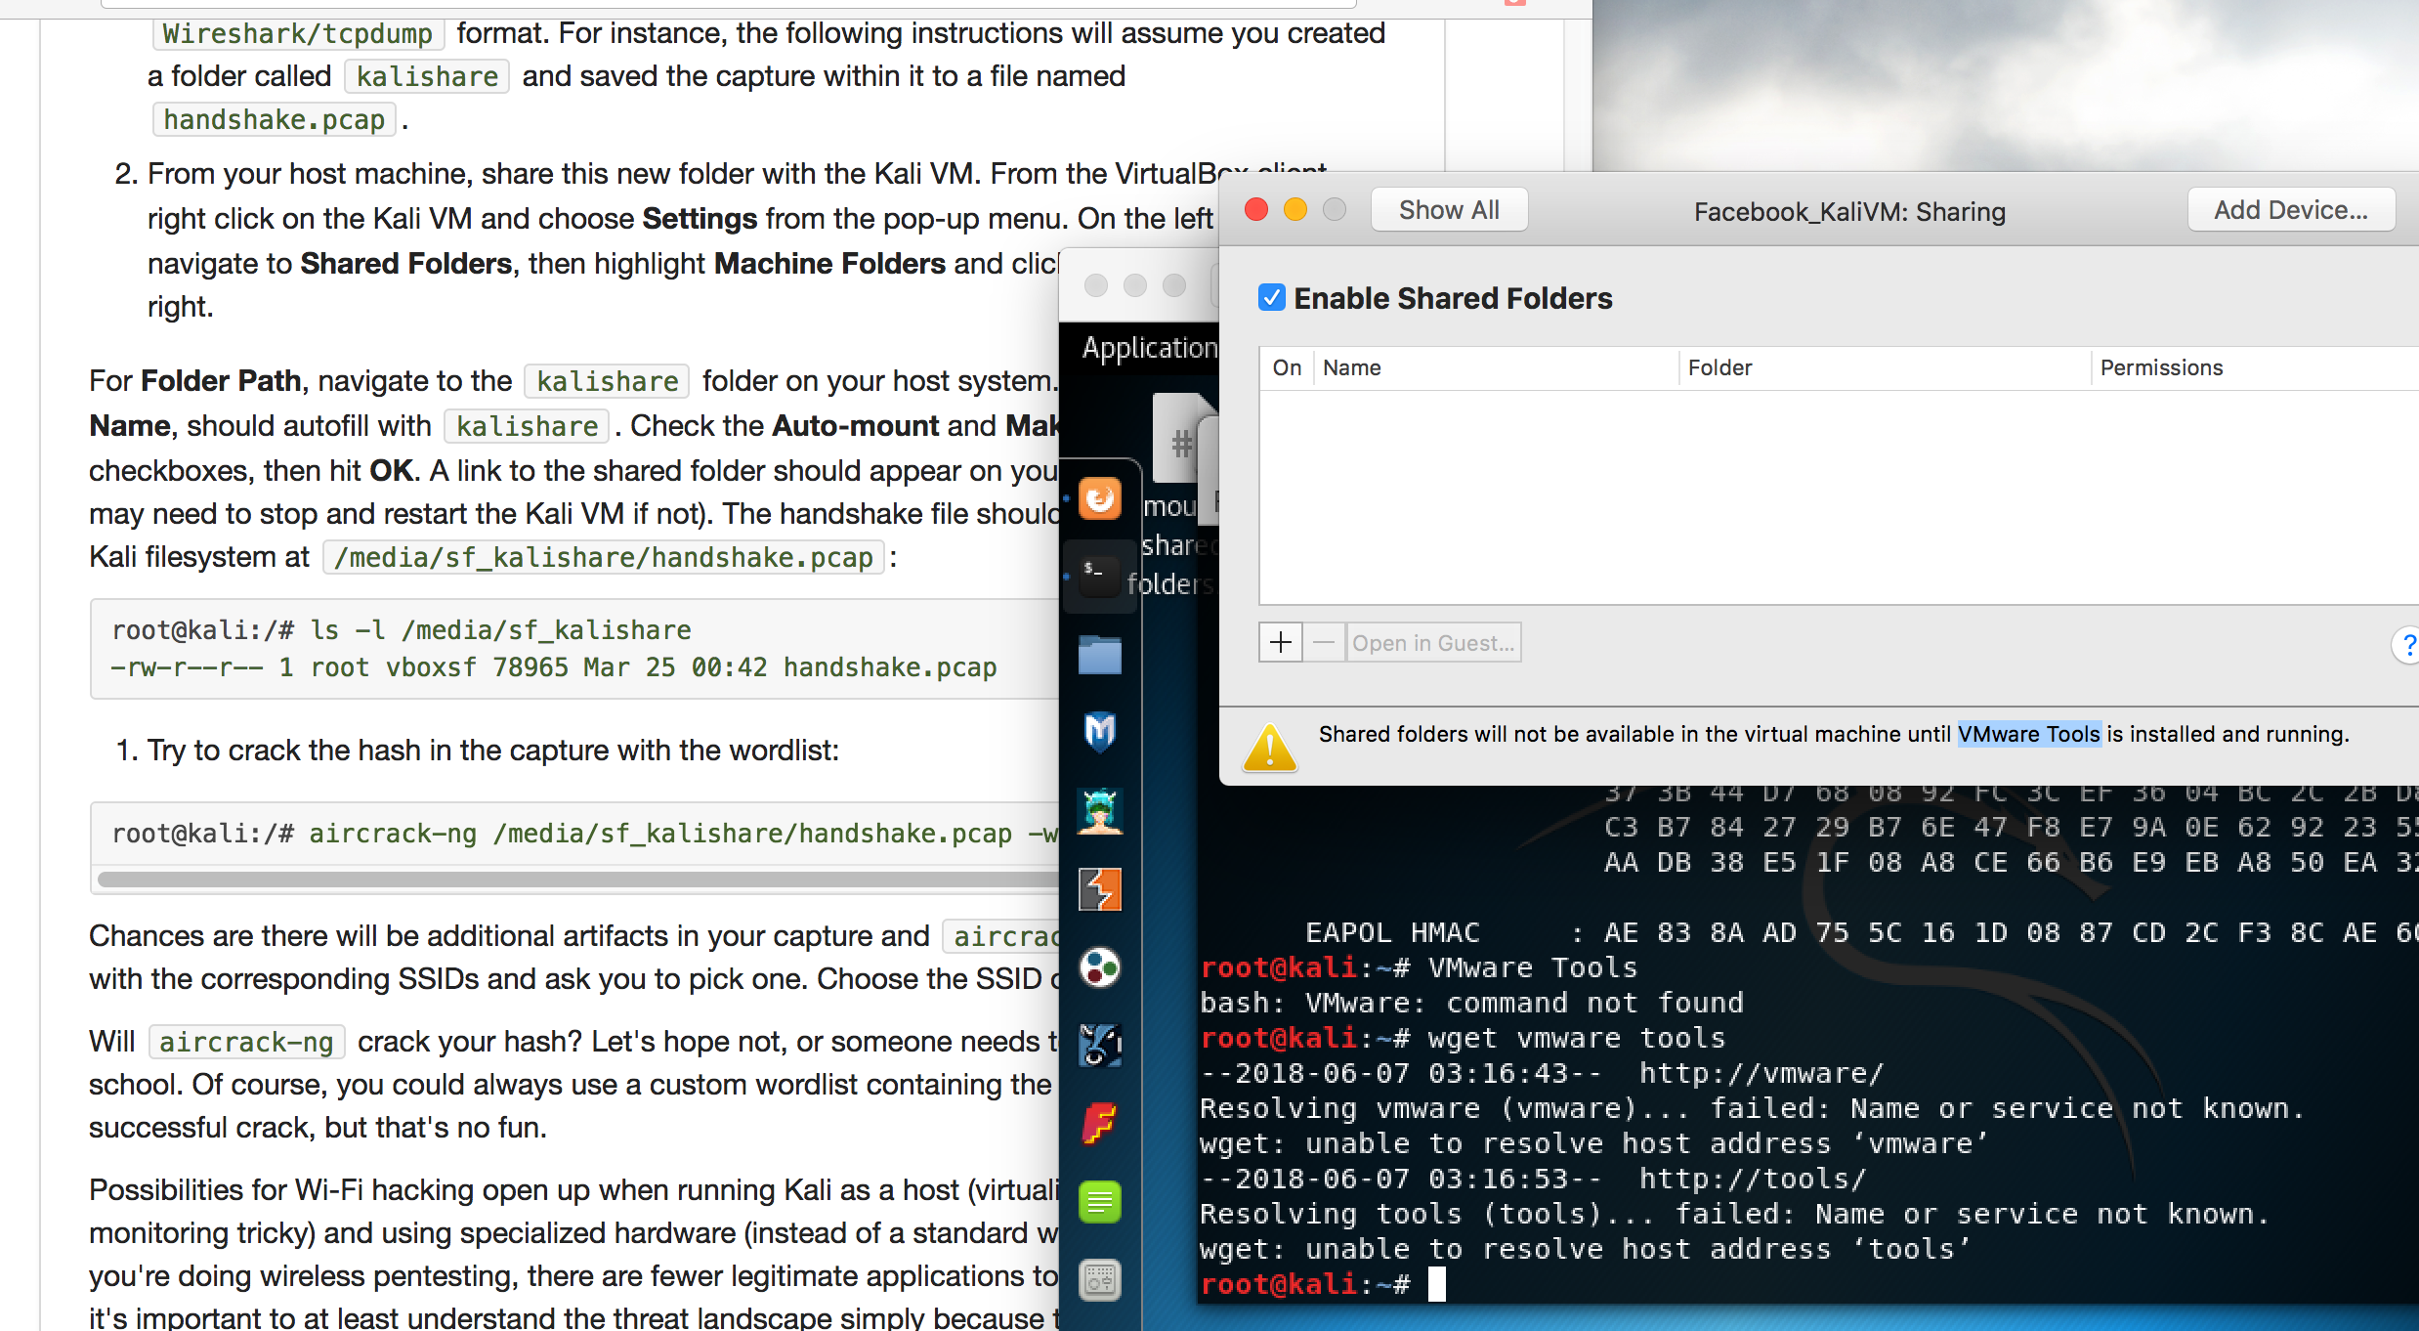

I created a new folder and named it kalishare but saw no option to share it with my Kali VM. On my Kali VM I also saw that I couldn’t do folder sharing. I tried to get the VMware tools through the command line which didn’t work.